

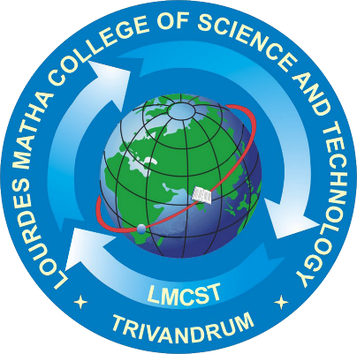

DEPARTMENT OF COMPUTER APPLICATIONS

(Affiliated to APJ Abdul Kalam Technological University, Kerala (KTU))

ROI – FACE RECOGNITION BASED ATTENDANCE AND ALERT SYSTEM

**LOURDES MATHA COLLEGE OF SCIENCE AND TECHNOLOGY KUTTICHAL, THIRUVANANTHAPURAM-695574**

**(MANAGED BY THE ARCHDIOCESE OF CHANGANASSERY)**

Submitted by:

**DON J VELLATHOTTAM**

**LMC21MCA2018**

**MINI-PROJECT REPORT**

|  |
| --- |
| **ROI – FACE RECOGNITION BASED ATTENDANCE AND ALERT SYSTEM** |
| **A Project Report** |
| ***Submitted By:*** |
| **Don J Vellathottam** **- LMC21MCA2018** |
| *in partial fulfillment of the requirements for the award of*  *the degree in* |
| **MASTER OF COMPUTER APPLICATIONS**  *at* |
|  |
| **DEPARTMENT OF COMPUTER APPLICATIONS**  **LOURDES MATHA COLLEGE OF SCIENCE AND TECHNOLOGY KUTTICHAL, THIRUVANANTHAPURAM-695574** |
| **(AFFILIATED TO APJ ABDUL KALAM TECHNOLOGICAL UNIVERSITY, KERALA)**  **NOVEMBER 2022** |
| |  |  |  | | --- | --- | --- | | **LOURDES MATHA COLLEGE OF SCIENCE AND TECHNOLOGY** | | | | **KUTTICHAL, THIRUVANANTHAPURAM – 695574**  **(Affiliated to APJ Abdul Kalam Technological University, Kerala)** | | | | **DEPARTMENT OF COMPUTER APPLICATIONS** | | | |  | | | | **CERTIFICATE** | | | | This is to certify that the project work entitled **“ROI – FACE RECOGNITION BASED ATTENDANCE AND ALERT SYSTEM”** is a Bona fide record of the work done by **Mr. DON J VELLATHOTTAM**, Reg No **LMC21MCA2018**, student of Department of Computer Applications, Lourdes Matha College Of Science And Technology, Kuttichal, Thiruvananthapuram, affiliated to the APJ Abdul Kalam Technological University, Kerala from August 2022 to November 2022 in partial fulfillment of the requirements for the award of the Degree of Master of Computer Applications from APJ Abdul Kalam Technological University, Kerala. | | | | **Prof. Bismi K Charleys**  **(Internal Guide)** |  | **Date:** | | **Internal Examiner** |  | **Prof. Bismi K Charleys (Head of the Department)** | |